July 29, 2026
Brandon L. Nielsen
City of El Mirage, Human Resources
12145 NW Grand Avenue
El Mirage, AZ 85335

Please consider my application for the position of Information Technology Director for the City of El Mirage. I have the education and experience to be an asset to the community. My abilities have been developed over years of experience in both the business and government sectors. I have great respect for the chain of command. I am conscientious, open-minded, affable, honest, ethical, and consistent. My business, church, and political experience have endowed me with all of the attributes to become a successful Information Technology Director. I am a consensus builder. I offer high availability / accessibility. I am adaptable and work exceptionally well in a dynamic situation. I listen well. I am diplomatic when appropriate, and direct as needed. I possess excellent public relations skills. I am forward thinking, embracing new concepts, theories, and technologies. I offer my well-developed leadership skills in addition to my energetic, optimistic and enthusiastic attitude.

I have not only served in public life, but I also run a small technology business. Having been on both the technology supplier as well as the government implementer side, I am you ideal candidate.

My ideal position is one that challenges me. I thrive under responsibility and pressure. I have excellent people skills. I am confident directing others, but I also work with those under me to instill confidence and a healthy working environment.

I look forward to hearing from you. I know we can put my experience to good use in the City of El Mirage. I currently live in Blooming Grove, New York. The address provided on my cover letter is the current address of my family in Arizona. This address would be my temporary address until I relocate my family. I look forward to becoming an integral part of the community.

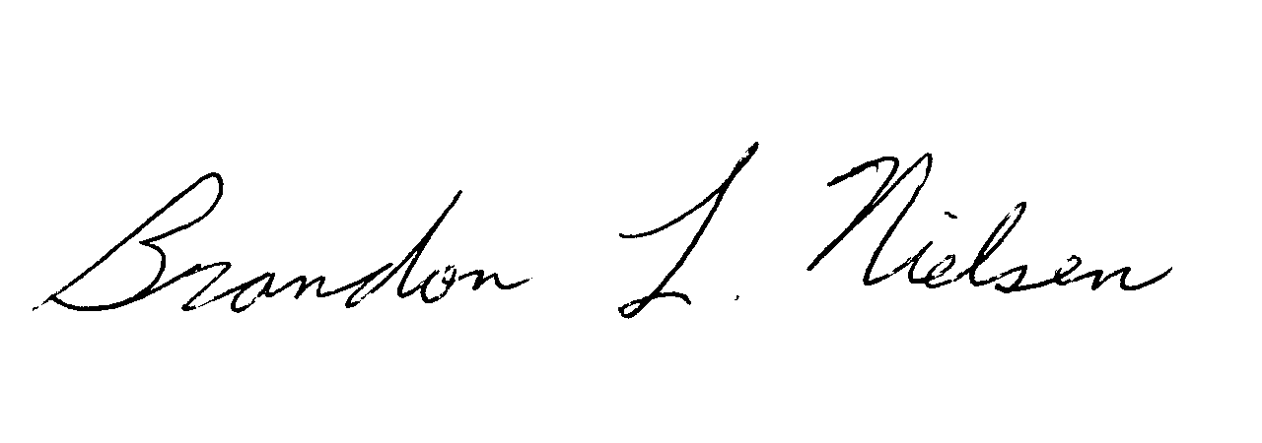
Sincerely,
Brandon L. Nielsen
17229 North Zuni Trail
Surprise, AZ 85374
Phone: (845) 774-6991
Fax: (845) 469-5719

